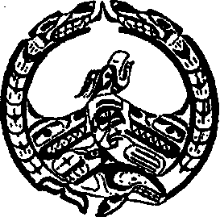
Nuchatlaht
P.O. Box 40, Zeballos B.C.
V0P 2A0
Phone: 250-332-5908
Fax: 250-332-5907

COVID-19 and Christmas Present Funds Registration
December 11th, 2020

Dear Nuchatlaht Tribe Membership:
Nuchatlaht Tribe will be dispensing COVID-19 and Christmas Present funds to registered Nuchatlaht members. It will be deposited into your bank account next week once registration is completed.

If you have not yet given us your Direct deposit information, please visit http://www.nuchatlaht.com/forms.html to download our Direct Deposit application.

Name: ________________________ Status Number: _______________________

Name: ________________________ Status Number:_______________________
Name:________________________ Status Number:_______________________

Name:________________________ Status Number:_______________________
Send to Audrey Smith: audrey.smith@nuchatlaht.com or fax to 250-332-5907

Deadline for registration submissions is Tuesday, December 15th, 2020 at 12:00pm. Our office will be closed after Friday, December 18, 2020.

