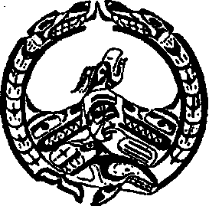
Nuchatlaht Tribe Administration
P.O. Box 40, Zeballos B.C.
V0P 2A0
Phone: 250-332-5908
Fax: 250-332-5907
Email: health@nuchatlaht.com

Confidential Medical Travel for Community Health Rep. Files
Name of Client:
Birthdate:
Status #:
Mailing Address:
Contant Info
Phone #:
Email:
Care Card #:

Appointment Date: Appointment Time:

Date: Leaving Home: Time: Leaving Home:

Date: Returning Home: Time: Return Home:

Purpose of Appointment: Doctor, Dentist, Surgeon, Rheumatology, optometry, IRS Councilling,
Chiropractic, etc.

Referral Letter from Dr. Attach Copy of referral

Escort Name: Own Vehicle Other
From Town: To Town:
Taxi: From: To:
Bus: From: To:
Km’s From: To:
Accommodations
Commercial-Hotel Check In: Check Out

Private $30 Per Night How Many Nights?

Purchase Order for Gas at Quinsam Crossing Shell in CR Zeballos
If no Purchase Order is required, your Travel difference will be deposited into your banking account on the next business day.

