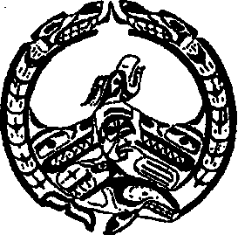
Nuchatlaht Tribe Administration
P.O. Box 40, Zeballos B.C.
V0P 2A0
Phone: 250-332-5908
Fax: 250-332-5907

Confirmation Client attented appointment

Name of Client:

Date of appointment:
Time of appointment:

Hospital/Health Clinic
confirmation stamp / signature:

Please return to Community Health Representitive

