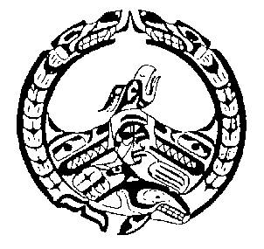
Nuchatlaht First Nation
Membership Support Application
This application is for a maximum of $200.00 in support per member that is applying. You may apply for funding on behalf of your children if they are also registered with our Nation. Applications can be submitted once per fiscal year (April 2022- March 2023)
Name: | Date:
Mailing Address:
Phone: | Email Address:
I am applying to be considered for Membership Support funds for the following reason:
Please list the names of registered Nuchatlaht Band Members included in this application, including name of applicant
Name: | Date of Birth: (mm/dd/yyyy) | Nuchatlaht Band Status Number
Please ensure that your Direct Deposit information is up to date with our office prior to submitting your application to avoid delays. Our Direct Deposit form can be found on our website at the following: www.Nuchatlaht.com/forms
Is your Direct Deposit information up-to-date with the Nuchatlaht Office? ☐ Yes ☐ No
Initial:
_______ I certify that I have exhausted every other avenue of income assistance and the Nuchatlaht Membership
support is my last alternative.
_______ I certify the above information to be true
Applicant’s Signature Date:
Band Administrator’s Signature Date:

